**### Project 01

### Deploying a Node.js App Using Minikube Kubernetes

#### Overview

This project guides you through deploying a Node.js application using Minikube Kubernetes. You'll use Git for version control, explore branching and fast-forward merges, and set up Kubernetes services and deployment pods, including ClusterIP and NodePort service types.

#### Prerequisites

* Minikube installed

* kubectl installed

* Git installed

* Node.js installed ([https://nodejs.org/en/download/package-manager/all#debian-and-ubuntu-based-linux-distributions](https://nodejs.org/en/download/package-manager/all#debian-and-ubuntu-based-linux-distributions))

#### Project Steps

### 1. Set Up Git Version Control

1.1. Initialize a Git Repository

Create a new directory for your project:

mkdir nodejs-k8s-project

cd nodejs-k8s-project

**

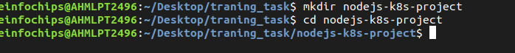

**Initialize a Git repository:

git init

1.2. Create a Node.js Application

Initialize a Node.js project:

npm init -y

Install Express.js:

npm install express

**

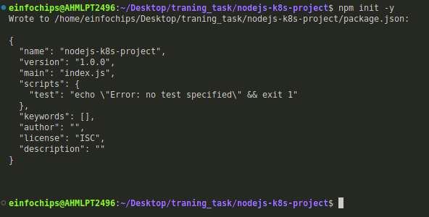

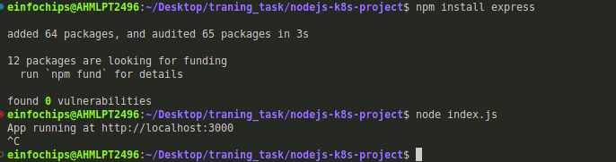

**1.3. Commit the Initial Code

Add files to Git:

git add .

Commit the changes:

git commit -m "Initial commit with Node.js app"**

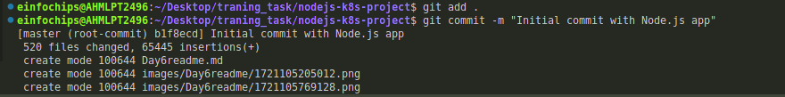

**### 2. Branching and Fast-Forward Merge

2.1. Create a New Branch

Create and switch to a new branch feature/add-route:

git checkout -b feature/add-route

**

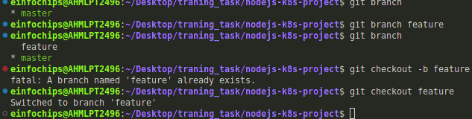

**2.2. Implement a New Route

Modify index.js to add a new route:

app.get('/newroute', (req, res) => {

res.send('This is a new route!');

});

Commit the changes:

git add .

git commit -m "Add new route"

**



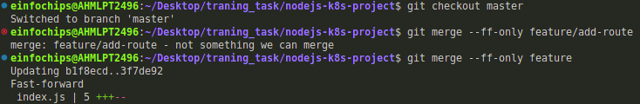

**2.3. Merge the Branch Using Fast-Forward

Switch back to the main branch:

git checkout main

Merge the feature/add-route branch using fast-forward:

git merge --ff-only feature/add-route

Delete the feature branch:

git branch -d feature/add-route

**

**### 3. Containerize the Node.js Application

3.1. Create a Dockerfile

Create a Dockerfile with the following content:

FROM node:14

WORKDIR /app

COPY package\*.json ./

RUN npm install

COPY . .

EXPOSE 3000

CMD ["node", "index.js"]

3.2. Build and Test the Docker Image

Build the Docker image:

docker build -t nodejs-k8s-app .

Run the Docker container to test:

docker run -p 3000:3000 nodejs-k8s-app

1. Access http://localhost:3000 to see the app running.

**

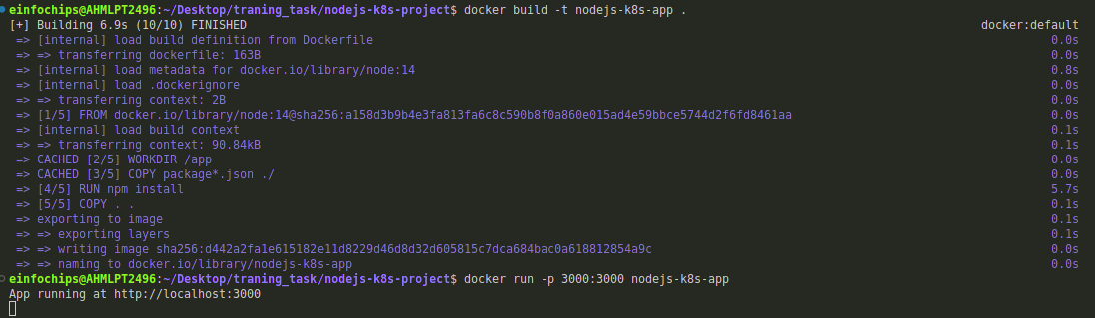

Ouput:

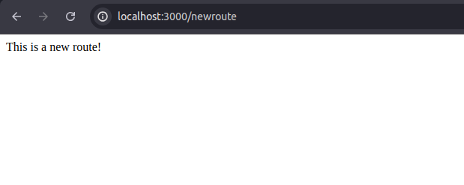

**### 4. Deploying to Minikube Kubernetes

4.1. Start Minikube

Start Minikube:

minikube start**

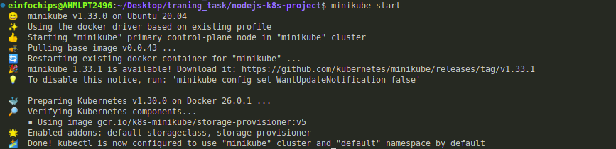

**4.3. Apply Manifests to Minikube

Apply the deployment:

kubectl apply -f deployment.yaml

Apply the ClusterIP service:

kubectl apply -f service.yaml

Apply the NodePort service:

kubectl apply -f service-nodeport.yaml

4.4. Access the Application

Get the Minikube IP:

minikube ip

Access the application using the NodePort:

curl http://<minikube-ip>:30001**

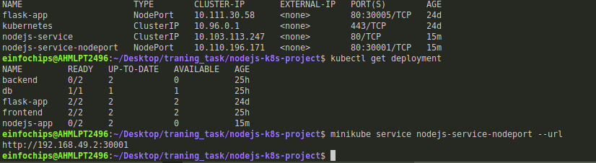

by hitting the ip :

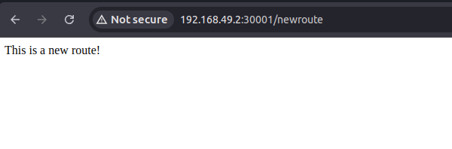

**### Making Changes to the App and Redeploying Using Kubernetes

### 6. Making Changes to the Node.js Application

6.1. Create a New Branch for Changes

Create and switch to a new branch feature/update-message:

git checkout -b feature/update-message

6.2. Update the Application

Modify index.js to change the message:

const express = require('express');

const app = express();

const port = 3000;

app.get('/', (req, res) => {

res.send('Hello, Kubernetes! Updated version.');

});

app.get('/newroute', (req, res) => {

res.send('This is a new route!');

});

app.listen(port, () => {

console.log(\`App running at http://localhost:\${port}\`);

});

6.3. Commit the Changes

Add and commit the changes:

git add .

git commit -m "Update main route message"

**

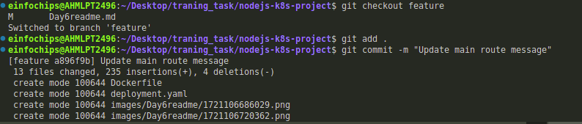

**### 7. Merge the Changes and Rebuild the Docker Image

7.1. Merge the Feature Branch

Switch back to the main branch:

git checkout main

Merge the feature/update-message branch:

git merge --ff-only feature/update-message

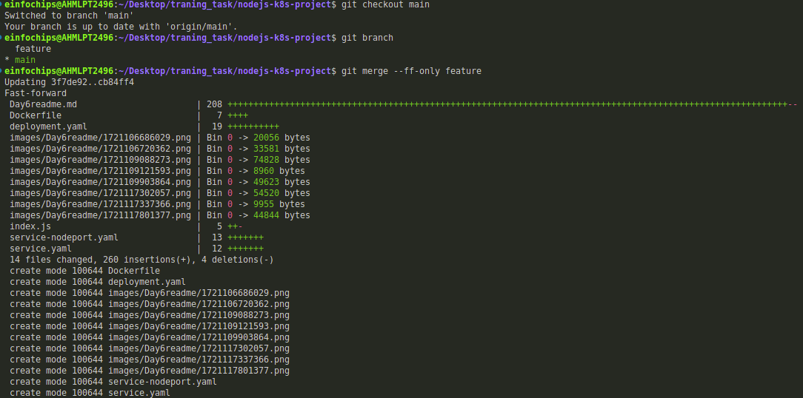

Delete the feature branch:

git branch -d feature/update-message

7.2. Rebuild the Docker Image

Rebuild the Docker image with a new tag:

docker build -t nodejs-k8s-app:v2 .

**

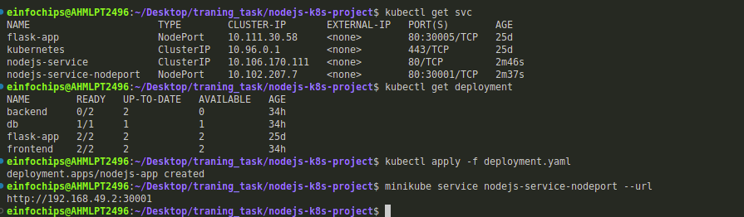

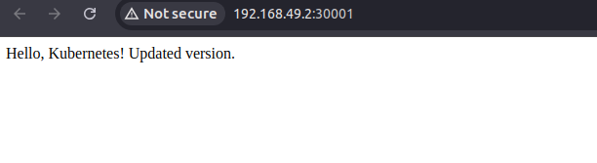

**### 9. Access the Updated Application

9.1. Access Through ClusterIP Service

Forward the port to access the ClusterIP service:

kubectl port-forward service/nodejs-service 8080:80

1. Open your browser and navigate to http://localhost:8080 to see the updated message.

9.2. Access Through NodePort Service

Access the application using the NodePort:

curl http://<minikube-ip>:30001**

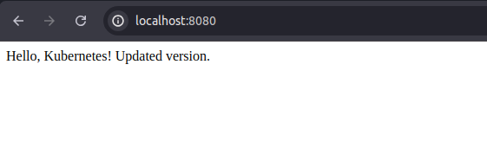

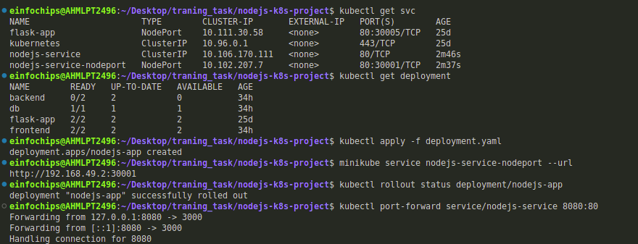

#### **Overview**

This project guides you through deploying a Python Flask application using Minikube Kubernetes. You'll use Git for version control, explore branching and fast-forward merges, and set up Kubernetes services and deployment pods, including ClusterIP and NodePort service types.

#### **Prerequisites**

* Minikube installed
* kubectl installed
* Git installed
* Python installed

#### **Project Steps**

### **1. Set Up Git Version Control**

**1.1. Initialize a Git Repository**

Create a new directory for your project:  
  
mkdir flask-k8s-project

cd flask-k8s-project

Initialize a Git repository:  
sh  
Copy code  
git init

**1.2. Create a Python Flask Application**

Create a virtual environment:  
  
python -m venv venv

source venv/bin/activate

Install Flask:  
sh  
Copy code  
pip install Flask

Create an app.py file with the following content:  
python  
Copy code  
from flask import Flask

app = Flask(__name__)

@app.route('/')

def hello_world():

return 'Hello, Kubernetes!'

if __name__ == '__main__':

app.run(host='0.0.0.0', port=5000)

Create a requirements.txt file to list the dependencies:  
Copy code  
Flask

Create a .gitignore file to ignore venv:  
Copy code  
venv

**1.3. Commit the Initial Code**

Add files to Git:  
  
git add .

Commit the changes:  
  
git commit -m "Initial commit with Flask app"

### **2. Branching and Fast-Forward Merge**

**2.1. Create a New Branch**

Create and switch to a new branch feature/add-route:  
  
git checkout -b feature/add-route

**2.2. Implement a New Route**

Modify app.py to add a new route:  
  
@app.route('/newroute')

def new_route():

return 'This is a new route!'

Commit the changes:  
  
git add .

git commit -m "Add new route"

**2.3. Merge the Branch Using Fast-Forward**

Switch back to the main branch:  
  
git checkout main

Merge the feature/add-route branch using fast-forward:  
  
git merge --ff-only feature/add-route

Delete the feature branch:  
  
git branch -d feature/add-route

### **3. Containerize the Flask Application**

**3.1. Create a Dockerfile**

Create a Dockerfile with the following content:  
  
FROM python:3.8-slim

WORKDIR /app

COPY requirements.txt requirements.txt

RUN pip install -r requirements.txt

COPY . .

EXPOSE 5000

CMD ["python", "app.py"]

**3.2. Build and Test the Docker Image**

Build the Docker image:  
  
docker build -t flask-k8s-app .

Run the Docker container to test:  
  
docker run -p 5000:5000 flask-k8s-app

1. Access http://localhost:5000 to see the app running.

### **4. Deploying to Minikube Kubernetes**

**4.1. Start Minikube**

Start Minikube:  
  
minikube start

**4.2. Create Kubernetes Deployment and Service Manifests**

Create a deployment.yaml file:  
  
apiVersion: apps/v1

kind: Deployment

metadata:

name: flask-app

spec:

replicas: 2

selector:

matchLabels:

app: flask-app

template:

metadata:

labels:

app: flask-app

spec:

containers:

- name: flask-app

image: flask-k8s-app:latest

ports:

- containerPort: 5000

Create a service.yaml file for ClusterIP:  
  
apiVersion: v1

kind: Service

metadata:

name: flask-service

spec:

selector:

app: flask-app

ports:

- protocol: TCP

port: 80

targetPort: 5000

type: ClusterIP

Create a service-nodeport.yaml file for NodePort:  
  
apiVersion: v1

kind: Service

metadata:

name: flask-service-nodeport

spec:

selector:

app: flask-app

ports:

- protocol: TCP

port: 80

targetPort: 5000

nodePort: 30001

type: NodePort

**4.3. Apply Manifests to Minikube**

Apply the deployment:  
  
kubectl apply -f deployment.yaml

Apply the ClusterIP service:  
  
kubectl apply -f service.yaml

Apply the NodePort service:  
  
kubectl apply -f service-nodeport.yaml

**4.4. Access the Application**

Get the Minikube IP:  
  
minikube ip

Access the application using the NodePort:  
  
curl http://<minikube-ip>:30001

### **5. Clean Up**

Stop Minikube:  
  
minikube stop

Delete Minikube cluster:  
  
minikube delete

### **6. Making Changes to the Flask Application**

**6.1. Create a New Branch for Changes**

Create and switch to a new branch feature/update-message:  
  
git checkout -b feature/update-message

**6.2. Update the Application**

Modify app.py to change the message:  
  
@app.route('/')

def hello_world():

return 'Hello, Kubernetes! Updated version.'

@app.route('/newroute')

def new_route():

return 'This is a new route!'

**6.3. Commit the Changes**

Add and commit the changes:  
  
git add .

git commit -m "Update main route message"

### **7. Merge the Changes and Rebuild the Docker Image**

**7.1. Merge the Feature Branch**

Switch back to the main branch:  
  
git checkout main

Merge the feature/update-message branch:  
  
git merge --ff-only feature/update-message

Delete the feature branch:  
  
git branch -d feature/update-message

**7.2. Rebuild the Docker Image**

Rebuild the Docker image with a new tag:  
  
docker build -t flask-k8s-app:v2 .

### **8. Update Kubernetes Deployment**

**8.1. Update the Deployment Manifest**

Modify deployment.yaml to use the new image version:  
  
apiVersion: apps/v1

kind: Deployment

metadata:

name: flask-app

spec:

replicas: 2

selector:

matchLabels:

app: flask-app

template:

metadata:

labels:

app: flask-app

spec:

containers:

- name: flask-app

image: flask-k8s-app:v2

ports:

- containerPort: 5000

**8.2. Apply the Updated Manifest**

Apply the updated deployment:  
sh  
Copy code  
kubectl apply -f deployment.yaml

**8.3. Verify the Update**

Check the status of the deployment:  
sh  
Copy code  
kubectl rollout status deployment/flask-app

### **9. Access the Updated Application**

**9.1. Access Through ClusterIP Service**

Forward the port to access the ClusterIP service:  
  
kubectl port-forward service/flask-service 8080:80

1. Open your browser and navigate to http://localhost:8080 to see the updated message.

**9.2. Access Through NodePort Service**

1. Access the application using the NodePort:  
     
   curl http://<minikube-ip>:30001